Sales Performance Analysis
This dataset represents detailed transaction records from an online e-commerce platform, capturing essential information about customer orders, products sold, pricing, and fulfillment performance. Each entry corresponds to a single order and includes key attributes such as order number, customer name, order date, delivery status, and assigned supervisor. It provides a comprehensive view of sales operations across multiple Indian states, enabling analysis of sales performance, delivery efficiency, and profitability across different product categories and brands.
The dataset contains 14 columns including identifiers (Order_Number, State_Code), customer details (Customer_Name), product information (Product, Category, Brand), and financial metrics (Cost, Sales, Quantity, Total_Cost, Total_Sales). The Status column reflects the order’s fulfillment stage such as Delivered, Pending, or Cancelled, while the Assigned_Supervisor indicates who managed the order. Using this data, one can derive insights like total and average sales, profit margins, delivery success rates, supervisor performance, and state-wise sales distribution — making it ideal for business intelligence and performance reporting.

Summary Analysis
1. Total Order Counts
create view total_orders as
select count(distinct order_number) as total_order_count
from sales;

select * from total_orders;
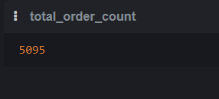

2. Total no. of products
create view total_products as
select count(distinct Product) as total_product_count
from sales;
select total_product_count from total_products;

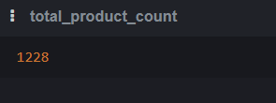
3. Total unique customers
create view unique_customers as
SELECT count(distinct customer_name) as unique_customer_count
from sales;

select unique_customer_count from unique_customers;
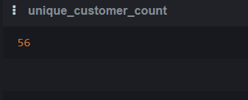
4. Total Sales and Profit
create view sales_and_profit as
select sum(total_sales) as sum_sales, sum(total_sales - total_cost) as sum_profit
from sales;

select * from sales_and_profit;

5. Average Order Value
create view AOV as
SELECT sum(total_cost) / count(DISTINCT order_number) as AOV
from sales;

select AOV from AOV;
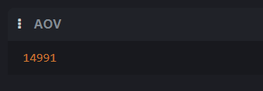
6. Total quantity sold
create view total_quantity as
select sum(quantity) as total_quantity
from sales;

SELECT * from total_quantity;
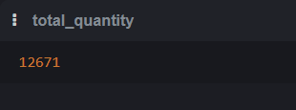

7. Top performing supervisors
create view supervisor_performance as
select assigned_supervisor, sum(quantity) as total_quantity, sum(total_sales) as total_sales
from sales
GROUP by assigned_supervisor
order by total_quantity desc, total_sales desc;

SELECT * from supervisor_performance;
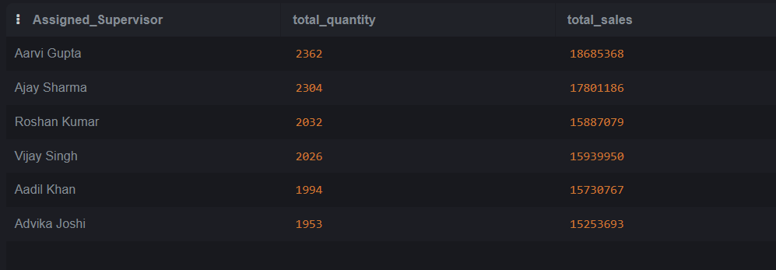
8. Top performing supervisors
create view state_performance as
select state_code, sum(quantity) as total_quantity, sum(total_sales) as total_sales
from sales
GROUP by state_code
order by total_quantity desc, total_sales desc;

SELECT * from state_performance;

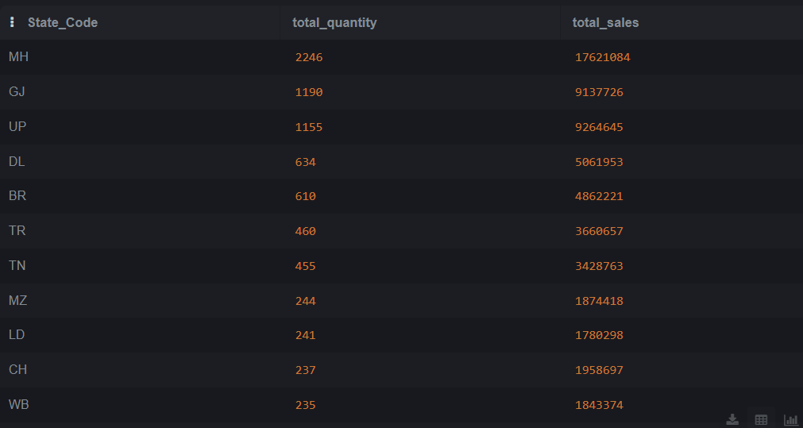
Sales & Profit Analysis
9. Daily Sales
create view daily_sales as
select order_date, sum(total_sales) as total_sales
from sales
GROUP by order_date;

select *
from daily_sales;
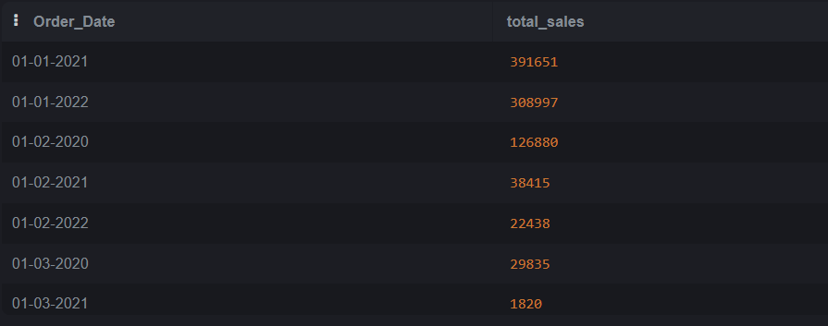
10. Profit margin by category
create view profit_by_category as
select category, sum(total_sales - total_cost) as profit
from sales
GROUP by category
order by profit desc;

select * from profit_by_category;
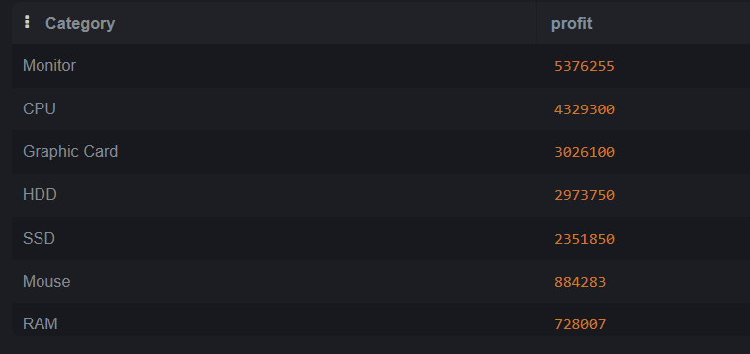
11. Profit margin by brand
create view profit_by_brand as
select brand, sum(total_sales - total_cost) as profit
from sales
GROUP by brand
order by profit desc;

select * from profit_by_brand;
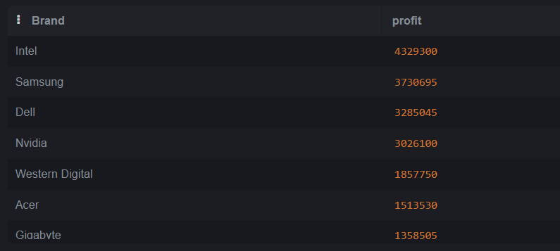
12. Profit margin by product
create view profit_by_product as
select product, sum(total_sales - total_cost) as profit
from sales
GROUP by product
order by profit desc;

select * from profit_by_product;
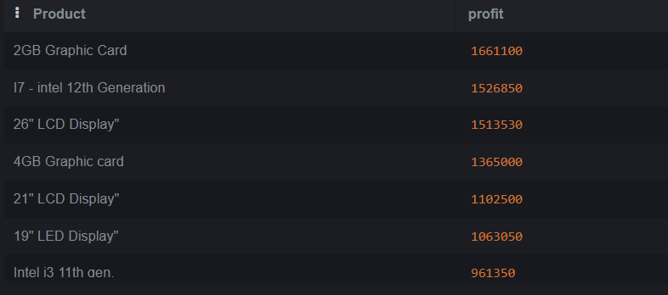

13. Top 10 product by sale_quantity
CREATE view top_10_product as
select product, sum(quantity) as total_quantity, sum(total_sales) as total_sale
from sales
GROUP by product
order by total_quantity desc , total_sale desc
limit 10;

select * from top_10_product;
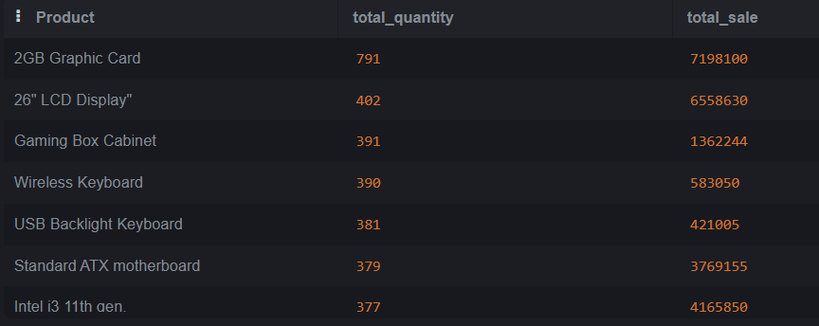
14. 100 Low performing products
create view low_performing_product as
select product, sum(quantity) as quantity_sold, sum(total_sales - total_cost) as profit_margin
from sales
GROUP by product
order by quantity_sold asc, profit_margin asc
limit 100;

select * from low_performing_product;
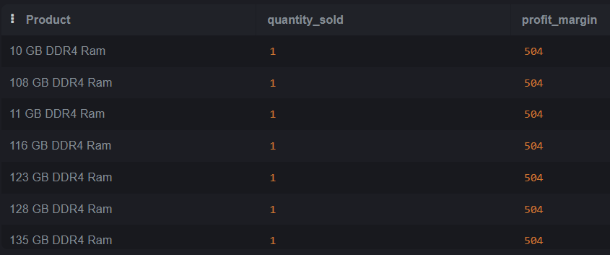

15. Region/State-wise sales performance
CREATE view state_wise_sales_performance as
select state_code, sum(quantity) as quantity_sold, sum(total_sales - total_cost) as profit_margin
from sales
GROUP by state_code;

select * from state_wise_sales_performance;
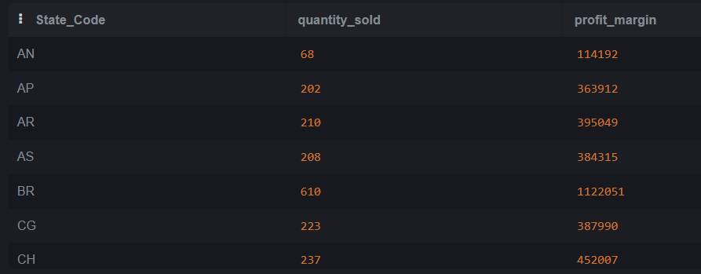
3. Product Analysis
16. Best-selling product categories
CREATE view category_wise_performance as
select lower(category) as category_smallcase, sum(quantity) as quantity_sold, sum(total_sales - total_cost) as profit_margin
from sales
GROUP by lower(category)
order by quantity_sold desc, profit_margin desc;

select * from category_wise_performance;
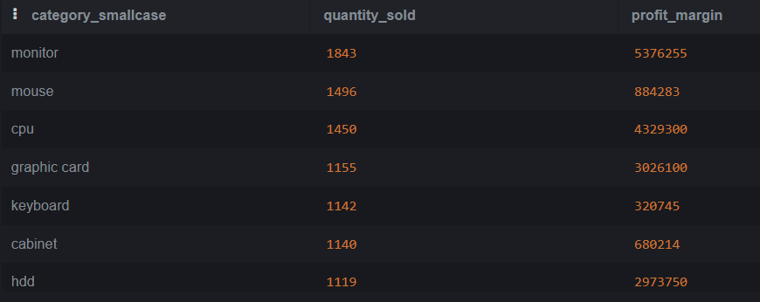
16. Best-selling product categories , brand-comparision
CREATE view category_wise_brand_performance as
select category,brand, sum(quantity) as quantity_sold, sum(total_sales - total_cost) as profit_margin
from sales
GROUP by category, brand
order by category, quantity_sold desc, profit_margin desc;

select * from category_wise_brand_performance;
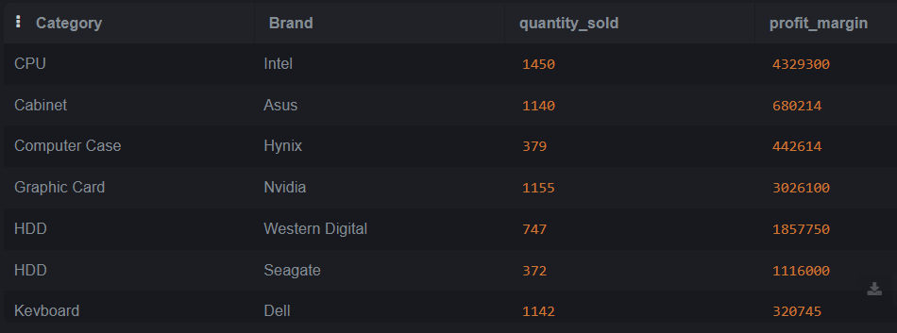
17. Average profit per product
create VIEW avg_profit_per_product as
select product, avg(total_sales-total_cost) as average_profit_per_product
from sales
GROUP by product;

select * from avg_profit_per_product;
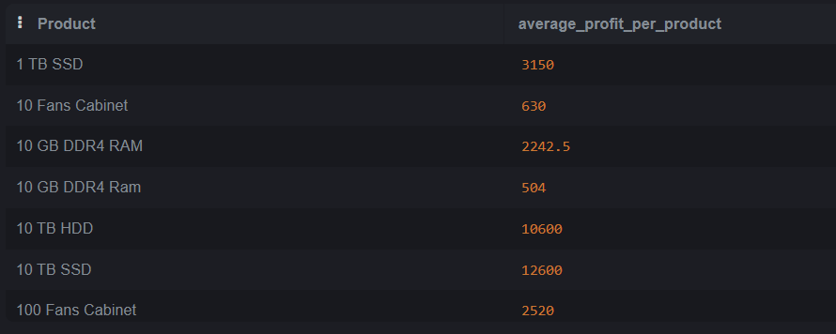

4. Customer Analysis
18. Top 10 customers by total purchase value
CREATE view top_10_customer as
select customer_name, sum(total_sales) as total_sale_value
from sales
GROUP by customer_name
order by total_sale_value desc
limit 10;

select * from top_10_customer;
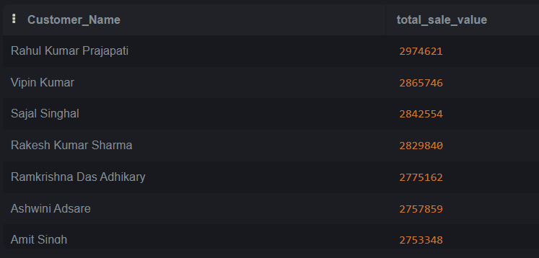

19. Number of unique customers per state
CREATE view no_of_customer_per_state as
SELECT state_code, count(distinct customer_name) as unique_customers
from sales
GROUP by state_code;

select * from no_of_customer_per_state;
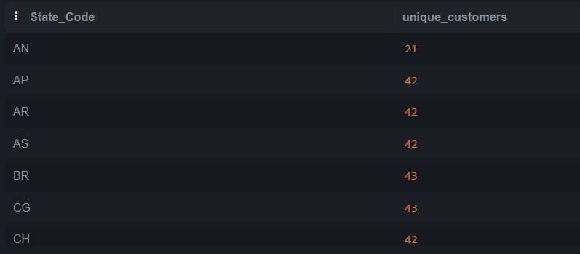
20. Average purchase value per customer
create view avg_purchase_value_by_customer as
select customer_name, avg(total_sales) as avg_purchase_value
from sales
GROUP by customer_name
order by avg_purchase_value desc;

select * from avg_purchase_value_by_customer;
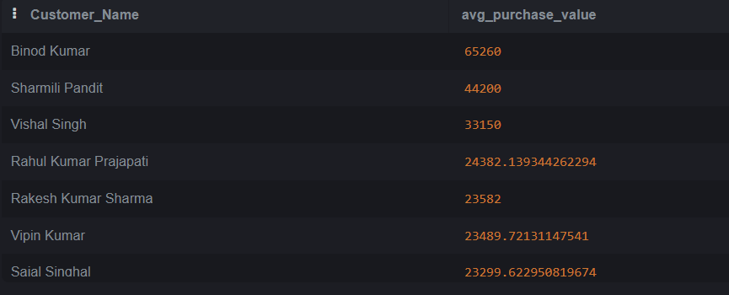
21 Status Distribution
create view status_distribution as
SELECT
Status,
COUNT(*) AS Total_Orders
FROM sales
GROUP BY Status
ORDER BY Total_Orders DESC;

select * from status_distribution;
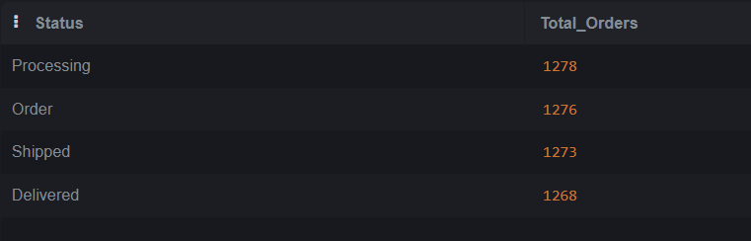

22. Delivery Success Rate
CREATE view delivery_success_rate as
SELECT
ROUND(
(SUM(CASE WHEN Status = 'Delivered' THEN 1 ELSE 0 END) * 100.0) / COUNT(*),
2
) AS Delivery_Success_Rate
FROM sales;

select * from delivery_success_rate;
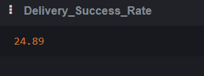

23. Supervisor-wise Order Fulfillment Performance
CREATE view supervisor_wise_order_fulfill_performance as
SELECT
Assigned_Supervisor,
COUNT(Order_Number) AS Total_Orders,
SUM(CASE WHEN Status = 'Delivered' THEN 1 ELSE 0 END) AS Delivered_Orders,
ROUND(
(SUM(CASE WHEN Status = 'Delivered' THEN 1 ELSE 0 END) * 100.0) / COUNT(Order_Number),
2
) AS Delivery_Success_Rate
FROM sales
GROUP BY Assigned_Supervisor
ORDER BY Delivery_Success_Rate DESC;

select * from supervisor_wise_order_fulfill_performance;

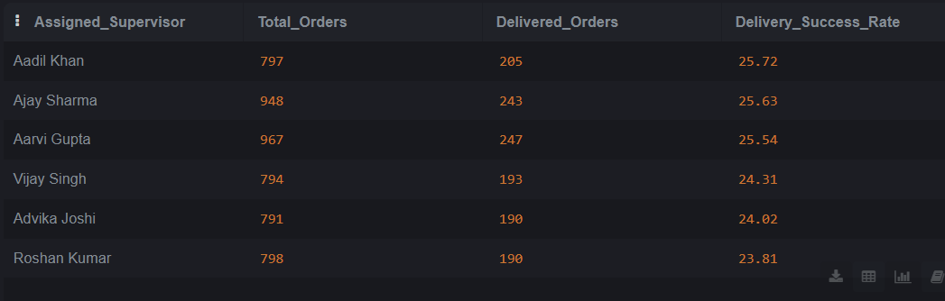

24 Total and Average Sales by Supervisor
CREATE view total_and_avg_sales_by_supervisors as
SELECT
Assigned_Supervisor,
SUM(Total_Sales) AS Total_Sales,
AVG(Total_Sales) AS Avg_Sales
FROM sales
GROUP BY Assigned_Supervisor
ORDER BY Total_Sales DESC;

select * from total_and_avg_sales_by_supervisors;
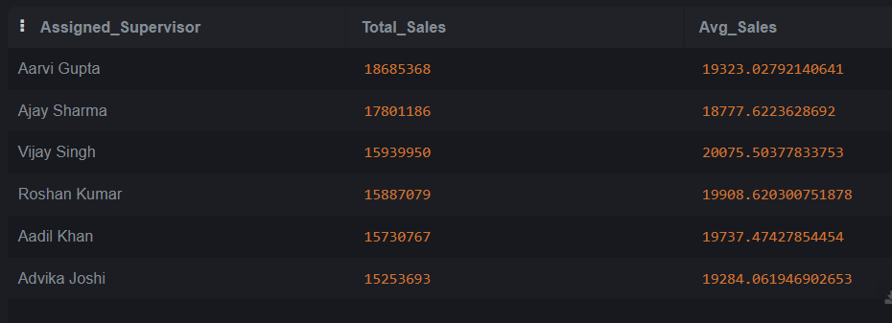

25 Number of Orders Handled by Each Supervisor
CREATE view Number_of_Orders_Handled_by_Each_Supervisor as
SELECT
Assigned_Supervisor,
COUNT(Order_Number) AS Total_Orders
FROM sales
GROUP BY Assigned_Supervisor
ORDER BY Total_Orders DESC;

select * from Number_of_Orders_Handled_by_Each_Supervisor;
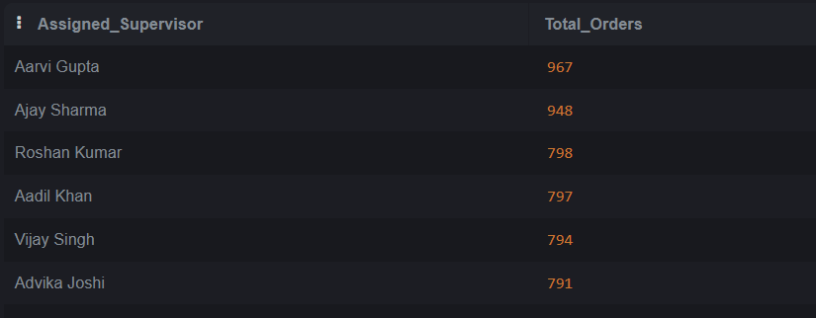

26. Profit Contribution per Supervisor
CREATE view Profit_Contribution_per_Supervisor as
SELECT
Assigned_Supervisor,
SUM(Total_Sales - Total_Cost) AS Total_Profit,
ROUND(AVG(Total_Sales - Total_Cost), 2) AS Avg_Profit_Per_Order
FROM sales
GROUP BY Assigned_Supervisor
ORDER BY Total_Profit DESC;

select * from Profit_Contribution_per_Supervisor;
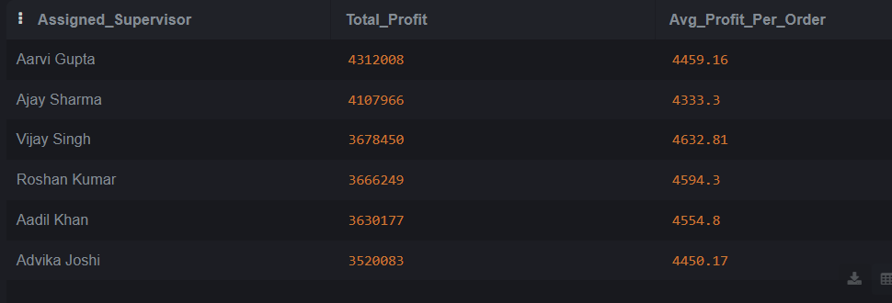

27. Comparison Dashboard by Supervisor (Sales, Profit, Delivery Success)
CREATE view Comparison_Dashboard_by_Supervisor as
SELECT
Assigned_Supervisor,
COUNT(Order_Number) AS Total_Orders,
SUM(Total_Sales) AS Total_Sales,
SUM(Total_Sales - Total_Cost) AS Total_Profit,
SUM(CASE WHEN Status = 'Delivered' THEN 1 ELSE 0 END) AS Delivered_Orders,
ROUND(
(SUM(CASE WHEN Status = 'Delivered' THEN 1 ELSE 0 END) * 100.0) / COUNT(Order_Number),
2
) AS Delivery_Success_Rate
FROM sales
GROUP BY Assigned_Supervisor
ORDER BY Total_Sales DESC;

select * from Comparison_Dashboard_by_Supervisor;
